Kamesh S
192521358
DWDM

LAB EXPERIMENTS

R PROGRAMMING

EXPERIMENT-1:
To prove the program for addition using R-tool.

Program:
a <- 10
b <- 20

sum <- a + b

print(sum)

Output Screenshot:
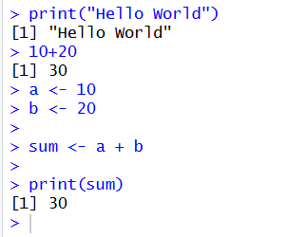

EXPERIMENT-2:
To prove the program for subtraction using R-tool.
Program:

# Program to subtract two numbers

a <- 30
b <- 10

difference <- a - b

print("First number:")
print(a)

print("Second number:")
print(b)

print("Difference:")
print(difference)

OUTPUT SCREENSHOT:
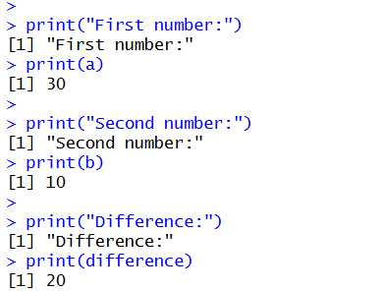

EXPERIMENT-3

To prove the program for multiplication using R-tool.
Program:

# Program to multiply two numbers

a <- 10
b <- 20

product <- a * b

print("First number:")
print(a)

print("Second number:")
print(b)

print("Product:")
print(product)

Output Screenshot:
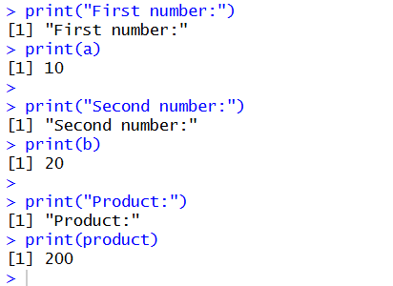

EXPERIMENT-4

To prove the program for division using R-tool.
Program:
# Program to divide two numbers

a <- 20
b <- 5

quotient <- a / b

print("First number:")
print(a)

print("Second number:")
print(b)

print("Quotient:")
print(quotient)

Output Screenshot:
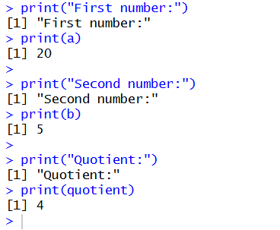

EXPERIMENT-5
To write the program for odd or even using R-tool.
Program:

# Program to check odd or even

num <- 10

if (num %% 2 == 0) {
print("The number is Even")
} else {
print("The number is Odd")
}

OUTPUT SCREENSHOT:
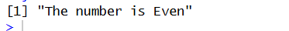

EXPERIMENT-6
To write the program for mean,median,mode.
Program:

# Program to calculate Mean, Median and Mode

numbers <- c(10, 20, 20, 30, 40)

# Calculate Mean
mean_value <- mean(numbers)

# Calculate Median
median_value <- median(numbers)

# Calculate Mode
mode_value <- as.numeric(names(
table(numbers)[table(numbers) == max(table(numbers))]
))

# Display the results
print("Numbers:")
print(numbers)

print("Mean:")
print(mean_value)

print("Median:")
print(median_value)

print("Mode:")
print(mode_value)

Output Screenshot:
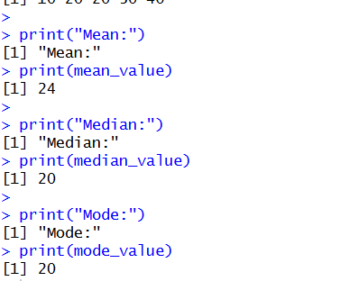

EXPERIMENT-7
To write the program for summary using R-tool.
Program:

# Create vectors
names <- c("siri", "mahi", "chiru")
age <- c(23, 24, 25)
marks <- c(88, 78, 25)

# Create a data frame
df <- data.frame(names, age, marks)

# Display summary of age
summary(df$age)

# Display the complete data frame
print(df)

# Write data frame to CSV file
write.csv(df, "datafr.csv", row.names = FALSE)

OUTPUT SCREENSHOT:
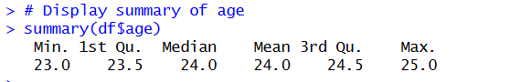

EXPERIMENT-8
To write the program for the greatest among three numbers.
Program:

# Program to find the greatest among three numbers

a <- 10
b <- 25
c <- 15

if (a >= b && a >= c) {
print("The greatest number is:")
print(a)
} else if (b >= a && b >= c) {
print("The greatest number is:")
print(b)
} else {
print("The greatest number is:")
print(c)
}

OUTPUT SCREENSHOT:
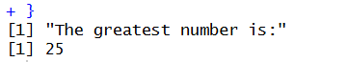

EXPERIMENT-9

To write the program for central tendency and data dispersion measures using R tool.

PROGRAM:

names <- c("siri", "mahi", "chiru")
age <- c(23, 24, 25)
marks <- c(88, 78, 25)

df <- data.frame(names, age, marks)

# Calculate IQR of age
IQR(df$age)

# Write data frame to CSV file
write.csv(df, "datafr.csv")

OUTPUT SCREENSHOT:
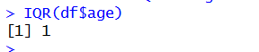

EXPERIMENT-10
QUANTILE:
To write the program for central tendency and data dispersion measures.
Program:
# Measures of Central Tendency and Data Dispersion

data <- c(10, 20, 20, 30, 40)

# Central Tendency
mean(data)
median(data)

# Mode
mode_value <- as.numeric(names(which.max(table(data))))
print(mode_value)

# Data Dispersion
range(data)
var(data)
sd(data)
IQR(data)

# Quantiles
quantile(data)

OUTPUT SCREENSHOT:
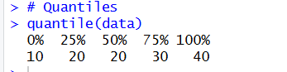

EXPERIMENT-11
MID RANGE:
To write the program for central tendency and data dispersion measures.
PROGRAM:
# Measures of Central Tendency and Data Dispersion

data <- c(10, 20, 20, 30, 40)

# Central Tendency
mean(data)
median(data)

# Mode
mode_value <- as.numeric(names(which.max(table(data))))
print(mode_value)

# Mid-Range
mid_range <- (min(data) + max(data)) / 2
print(mid_range)

# Data Dispersion
range(data)
var(data)
sd(data)
IQR(data)

OUTPUT SCREENSHOT:
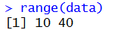

EXPERIMENT-12
Z-SCOORE NORMALIZATION:
To write the program for Z-scoore normalization using R-tool.
Program:
# Z-Score Normalization

data <- c(10, 20, 30, 40, 50)

mean_value <- mean(data)
sd_value <- sd(data)

z_score <- (data - mean_value) / sd_value

print("Original Data:")
print(data)

print("Z-Score Normalized Data:")
print(round(z_score, 2))

OUTPUT SCREENSHOT:
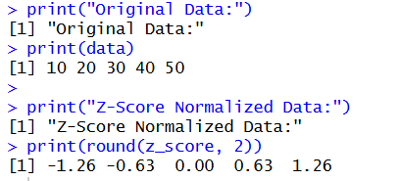
EXPERIMENT-13
MIN,MAX,MEAN,MINMAX:
To write the program for the minimum,maximum,mean and minmax using r-TOOL
PROGRAM:
# Minimum, Maximum, Mean and Min-Max Normalization

data <- c(10, 20, 30, 40, 50)

# Minimum Value
print(min(data))

# Maximum Value
print(max(data))

# Mean Value
print(mean(data))

# Min-Max Normalization
min_value <- min(data)
max_value <- max(data)

normalized_data <- (data - min_value) / (max_value - min_value)

print("Min-Max Normalized Data:")
print(round(normalized_data, 2))

OUTPUT SCREEBSHOT:
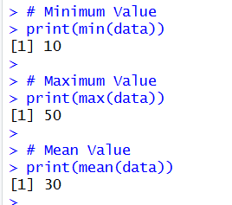
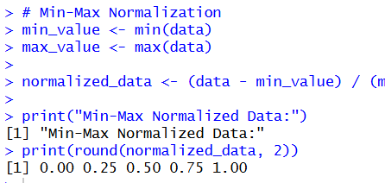

EXPERIMENT-14
BAR PLOT AND HORIZONTAL BAR:
To draw the bar plot and horizontal bar using R-tool.
PROGRAM:
# Bar Plot and Horizontal Bar Plot

# Create Data
students <- c(25, 30, 20, 35)
names <- c("CSE", "IT", "ECE", "EEE")

# Vertical Bar Plot
barplot(students,
names.arg = names,
main = "Department-wise Students",
xlab = "Departments",
ylab = "Number of Students",
col = "skyblue")

# Horizontal Bar Plot
barplot(students,
names.arg = names,
main = "Horizontal Bar Plot",
xlab = "Number of Students",
ylab = "Departments",
col = "lightgreen",
horiz = TRUE)

OUTPUT SCREENSHOT:
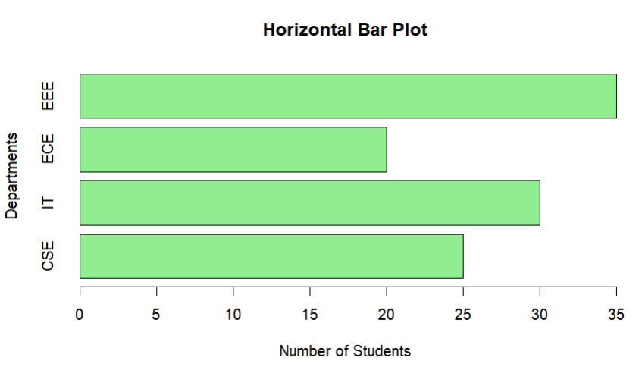

EXPERIMENT-15
BOX PLOT
To draw the box plot using R-tool.

PROGRAM:

# Box Plot

marks <- c(45, 50, 55, 60, 65, 70, 75, 80, 85, 90)

boxplot(marks,
main = "Box Plot of Student Marks",
xlab = "Students",
ylab = "Marks",
col = "lightblue",
border = "black")

OUTPUT SCREENSHOT:
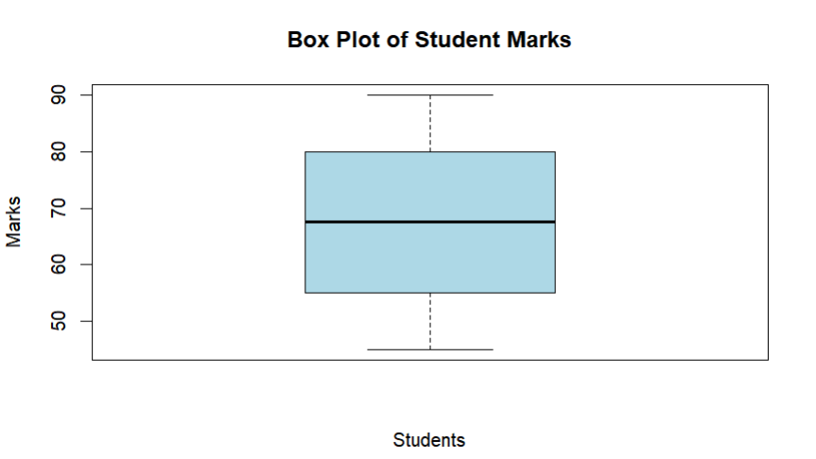

EXPERIMENT-16
HISTOGRAM:
To draw the histogram plot using R-tooll.
PROGRAM:
# Histogram Plot

marks <- c(45, 50, 55, 60, 65, 70, 75, 80, 85, 90)

hist(marks,
main = "Histogram of Student Marks",
xlab = "Marks",
ylab = "Frequency",
col = "skyblue",
border = "black")
OUTPUT SCREENSHOT:
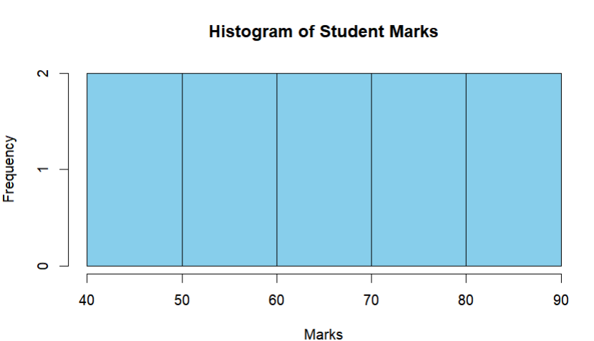
EXPERIMENT-17
CORRELATION ANALYSIS:
To write the program for correlation analysis using R-tool.
PROGRAM:
# Correlation Analysis
# Create Data
x <- c(10, 20, 30, 40, 50)
y <- c(15, 25, 35, 45, 55)
# Calculate Correlation
result <- cor(x, y)
# Display Result
print("Correlation Coefficient:")
print(result)

# Draw Scatter Plot
plot(x, y,
main = "Correlation Analysis",
xlab = "X Values",
ylab = "Y Values",
col = "blue",
pch = 19)

# Add Regression Line
abline(lm(y ~ x), col = "red")
Output screenshot:
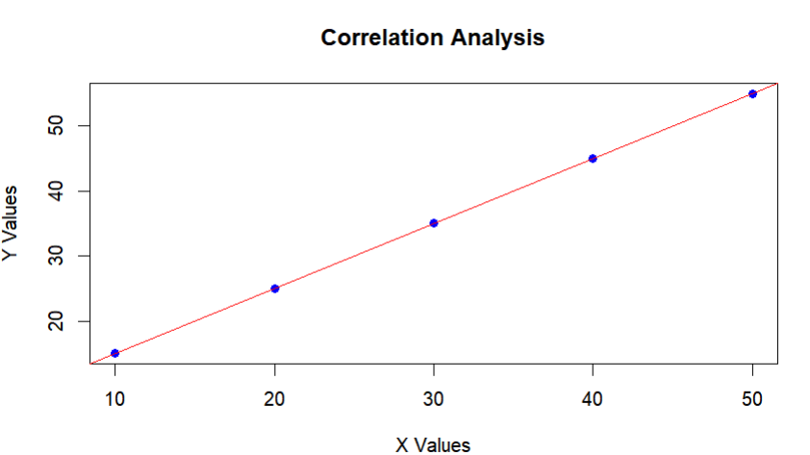
EXPERIMENT-18
SCATTER PLOT:
To draw the scatter plot using R-tool
PROGRAM:
# Scatter Plot

x <- c(10, 20, 30, 40, 50)
y <- c(15, 25, 20, 35, 45)

plot(x, y,
main = "Scatter Plot",
xlab = "X Values",
ylab = "Y Values",
col = "blue",
pch = 19)
OUTPUT SCREENSHOT:
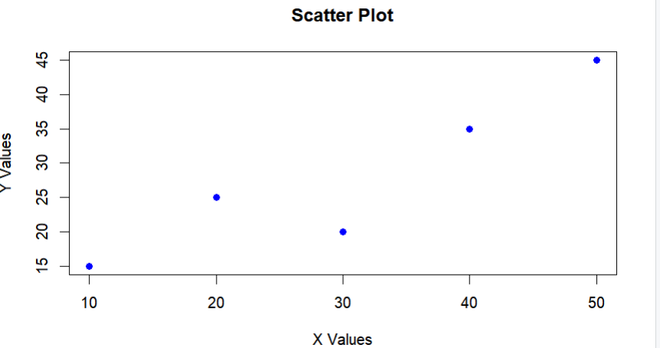
EXPERIMENT-19
LINEAR REGRESSION:
To write thr program for the linear regression using R-tool.
PROGRAM:
# Linear Regression

# Create Data
x <- c(1, 2, 3, 4, 5)
y <- c(2, 4, 5, 4, 5)

# Create Data Frame
data <- data.frame(x, y)

# Apply Linear Regression
model <- lm(y ~ x, data = data)

# Display Model Summary
print(summary(model))

# Predict Values
predicted <- predict(model)
print("Predicted Values:")
print(round(predicted, 2))

# Draw Scatter Plot
plot(x, y,
main = "Linear Regression",
xlab = "X Values",
ylab = "Y Values",
col = "blue",
pch = 19)

# Add Regression Line
abline(model, col = "red", lwd = 2)
OUTPUT SCREENSHOT:
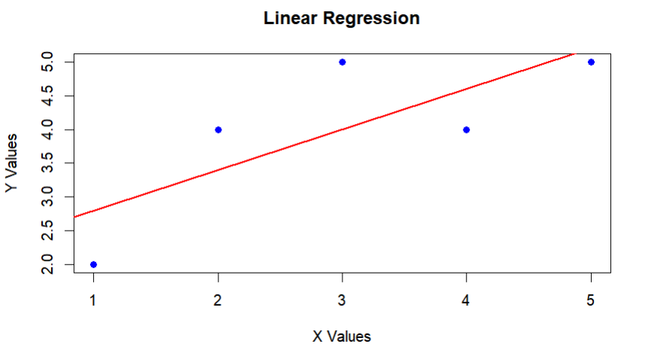
EXPERIMENT-20
MULTIPLE REGRESSION:
To write the program for the multiple regression.
PROGRAM:
# Multiple Regression

# Create Data
study_hours <- c(2, 3, 4, 5, 6)
attendance <- c(60, 65, 70, 80, 90)
marks <- c(50, 55, 65, 75, 85)

# Create Data Frame
data <- data.frame(study_hours, attendance, marks)

# Apply Multiple Regression
model <- lm(marks ~ study_hours + attendance, data = data)

# Display Model Summary
print(summary(model))

# Predict Marks
new_data <- data.frame(study_hours = 7, attendance = 95)
predicted_marks <- predict(model, newdata = new_data)

print("Predicted Marks:")
print(round(predicted_marks, 2))

OUTPUT SCREENSHOT:
